Mapúa University
PROJECT DOCUMENTATION

Modeling and Simulation of Roundabout Traffic Flow at the Quezon Memorial Circle (Elliptical Road) Using Discrete-Event Simulation, Queuing Theory, and Gap-Acceptance Models

Submitted by: Frank Charles Agliam
Course/Section: CSS142P / FOPM01
Instructor: Joel De Goma
Date: October 16, 2026

I. Title
Modeling and Simulation of Roundabout Traffic Flow at the Quezon Memorial Circle (Elliptical Road) Using Discrete-Event Simulation, Queuing Theory, and Gap-Acceptance Models

II. Introduction
Roundabouts are widely adopted intersection treatments because they reduce conflict points and generally improve safety and delay performance compared with conventional intersections (National Academies of Sciences, Engineering, and Medicine [NASEM], 2023). Their performance, however, depends heavily on driver behavior at the yield line, the balance of approach demands, and the geometry of the circulating roadway (Al Hasanat & Schuchmann, 2022; Majid & Jabari, 2023). Modeling and simulation (M&S) allows these interactions to be studied and tested virtually, without costly or risky field experimentation (Law, 2024).
This project focuses on the Quezon Memorial Circle, locally known as the Elliptical Road, in Quezon City, Philippines. It is a 1.98-km circulatory roadway that links six major arterials, namely Commonwealth Avenue, Quezon Avenue, East Avenue, North Avenue, Visayas Avenue, and Kalayaan Avenue. Because it serves as a transfer point for private vehicles, public utility vehicles, and pedestrians, it is a suitable case for evaluating how a roundabout behaves under heavy and uneven demand. Local studies of nearby intersections, such as the proposed Commonwealth Avenue–East Avenue interchange (Eugenio et al., 2023), show that simulation is already used to support planning in this area.
In this study, the researcher developed a discrete-event simulation (DES) in Python using SimPy as the main model. The model was supported by queuing theory as an analytical baseline, a gap-acceptance model of driver entry behavior, and the Highway Capacity Manual (HCM) 7th Edition entry capacity equation for validation (NASEM, 2022). The validated model was then used to compare improvement scenarios and to formulate evidence-based recommendations.

III. Problem Statement
Traffic at the Elliptical Road is believed to experience long queues and delays at its entry approaches during peak periods. However, there is no simple, validated model that can be used to measure these conditions and to compare possible improvements before they are implemented. Without such a model, decisions on signal metering, added lanes, demand growth, and pedestrian crossing locations rely on intuition rather than data. To address this problem, the study sought to answer three research questions.
The first research question asked what the current average delay, queue length, and entry capacity of each approach to the Elliptical Road are during peak periods, as estimated by queuing theory and by the discrete-event simulation. The second asked how closely the simulated entry capacities and delays agree with the analytical baseline and with the HCM 7th Edition capacity equation c = A·e^(−B·vc). The third asked how metering signals, an added entry or bypass lane, a 10–20% demand increase, and relocated pedestrian crossings change delay, queue length, and throughput relative to the baseline.

IV. Objectives

General Objective
The general objective of the study was to develop and validate a discrete-event simulation model of traffic flow at the Quezon Memorial Circle and to use it to evaluate operational improvement scenarios.

Specific Objectives
- Compile traffic volumes, vehicle classification, and entry headways for all six approaches for one weekday AM peak period (07:00–09:00). Field counts were not available, so planning-level values were used and identified as assumed.
- Analyze the system by computing arrival rates, service rates, and utilization for each approach, and by estimating the critical gap and follow-up headway using Raff's method and maximum likelihood estimation.
- Build a SimPy discrete-event model with approach queues, a gap-acceptance entry rule, and circulating flow, together with M/M/1 and M/G/1 results as an analytical baseline.
- Validate the model by running 30 replications with the warm-up period removed, reporting 95% confidence intervals, and comparing the results with the HCM capacity equation.
- Simulate the baseline, metering signals, an added entry lane, 10% and 20% demand increases, and relocated pedestrian crossings using the same performance measures.
- Rank the scenarios by delay, queue length, and throughput and give recommendations for consideration by the Quezon City local government unit (LGU) and the Metropolitan Manila Development Authority (MMDA).

V. Scope and Limitations

Scope
The study covers the Elliptical Road circulatory roadway and its six approaches, which are designated A1 Commonwealth, A2 Visayas, A3 North, A4 Quezon, A5 East, and A6 Kalayaan Avenue. The performance measures are average delay, queue length, entry capacity, utilization (degree of saturation), and throughput per approach. The main tool is the SimPy discrete-event model, supported by queuing theory, a gap-acceptance model, and HCM-based validation. The optional SUMO microsimulation with the Intelligent Driver Model was not performed because of time constraints. Five scenarios were examined against the baseline: a metering signal, an added entry lane, a demand increase of 10% and 20%, and relocated pedestrian crossings.

Limitations
The most important limitation is that no field data were collected. Demand, origin-destination shares, and the gap and headway samples are planning-level or seeded synthetic values, which the proposal marks as [X veh/hr] until collected. The results therefore show how the model behaves under stated assumptions and should not be read as a measurement of actual conditions at the circle. In addition, the HCM roundabout capacity model was developed for conventional roundabouts, so the large size of the Elliptical Road may reduce its accuracy. For this reason, the equation was used only as a validation reference (NASEM, 2022, 2023).
Driver behavior is also simplified to gap acceptance and follow-up headway. Lane changing, illegal parking, and road incidents are not modeled, and only the critical entry lane of each approach is represented. Finally, the scenarios were tested only in simulation and are not engineering designs, and their cost and construction feasibility are outside the scope of this study.

VI. Methodology
The project followed the seven steps of the proposal, which were adapted from the standard simulation study process described by Law (2024).
- Identify the problem. The system boundary, the six approaches, the performance measures, and the research questions were defined at the start of the study.
- Collect data. The model inputs were the peak demand of each approach (660, 300, 380, 620, 420, and 320 passenger car equivalents per hour for A1 to A6), the origin-destination shares, the 1.98-km circulating roadway with segment travel times of 55 to 65 seconds (a circulating speed of about 20 km/h), and pedestrian crossings at A1 and A4 (40 groups per hour, each blocking the entry for 12 seconds). Since field sheets were not available, a seeded synthetic sample in the format of the field sheets, consisting of counts, accepted and rejected gaps, and follow-up headways, was generated by the program.
- Design the model. The entities are vehicles and the resources are the entry lanes. Each approach has a first-in-first-out queue, and the decision rule at the yield line is gap acceptance. Exponential and Erlang interarrival times were tested against the sample before one was selected.
- Develop the simulation. The model was coded in Python with SimPy (roundabout_sim.py and roundabout_sim.ipynb). Vehicles arrive at an approach, wait in the queue, and enter when the gap in the circulating flow is at least the critical gap of 5.0 seconds, while the follow-up headway of 2.6 seconds applies to the next vehicle. The M/M/1 and M/G/1 baselines were computed from the same inputs.
- Verify and validate. Verification used trace checks, event-log checks, and extreme-value tests. Validation compared the outputs with the HCM capacity equation c = A·e^(−B·vc), using A = 1380 and B = 0.00102, and with the M/M/1 and M/G/1 results. Thirty independent replications were run with a 15-minute warm-up removed, which was checked using Welch's method, and 95% confidence intervals were reported.
- Analyze results. Scenario outputs were compared using confidence intervals, a one-way analysis of variance (ANOVA), and paired t-tests with Bonferroni adjustment. The same random seeds were used in every scenario (common random numbers) so that differences came from the scenario and not from sampling noise. A one-factor-at-a-time sensitivity analysis was also added.
- Give recommendations. The scenarios were ranked by delay, queue length, and throughput, and the conditions under which each option remains effective were noted.
Table 1 summarizes how each simulation method was applied in the study.
Table 1. Simulation methods and their application in the study
Method | How it is applied | Source
Queuing theory (M/M/1, M/G/1) | Each approach is treated as a single-server queue. Service rate is derived from entry capacity. Utilization, mean waiting time, and mean queue length serve as the analytical baseline. | Law (2024)
Discrete-event simulation (SimPy) | Main model. Arrivals, queueing, gap checks, and entries are events in a simulated clock. Outputs are delay, queue length, and throughput. | Law (2024)
Gap-acceptance model | Critical gap and follow-up headway are estimated using Raff's method and maximum likelihood and used as the entry rule. | Al Hasanat & Schuchmann (2022); Majid & Jabari (2023)
HCM 7th Ed. capacity equation | Entry capacity c = A·e^(−B·vc) is compared with the model capacity. | NASEM (2022)
Monte Carlo replications | Thirty replications with random seeds, warm-up removed, and 95% confidence intervals. | Law (2024)
SUMO with IDM (optional) | Not performed because of time constraints. | Guastella et al. (2023); Previati & Mastinu (2023)
Scenario analysis | Baseline, metering signal, added lane, +10% and +20% demand, and relocated crossings under the same inputs. | NASEM (2023); Tumminello et al. (2022)

VII. Results and Output
All values in this section were produced by the executed notebook using 30 replications, a 15-minute warm-up, and a 2-hour peak period. Because the inputs are assumed values, the results are documented model outputs and not field findings.

A. Input Analysis
The exponential distribution fit the headway samples well, with an average chi-square p-value of 0.57 and an average Kolmogorov-Smirnov (K-S) p-value of 0.77, while the Erlang (k = 2) distribution was rejected (p < 0.001). The model therefore uses exponential interarrival times. Only A4 failed the chi-square test (p = 0.01), although it passed the K-S test (p = 0.63). Table 2 shows that the estimated critical gaps and follow-up headways are consistent with the 5.0-second and 2.6-second values used in the model.
Table 2. Critical gap and follow-up headway estimates
Approach | Accepted / rejected gaps | Raff (s) | MLE mean (s) | MLE SD (s) | Follow-up (s)
A1 | 120 / 161 | 5.20 | 5.14 | 0.95 | 2.64
A2 | 120 / 124 | 4.71 | 4.82 | 0.46 | 2.54
A3 | 120 / 164 | 5.06 | 5.10 | 0.95 | 2.56
A4 | 120 / 158 | 4.99 | 5.05 | 1.02 | 2.58
A5 | 120 / 141 | 5.24 | 5.25 | 0.88 | 2.60
A6 | 120 / 146 | 5.25 | 5.24 | 0.88 | 2.63

B. Verification
Eight verification tests were conducted, and all of them passed (Table 3). In the limiting case where only one approach has demand and there is no circulating flow, the model reduces to an M/D/1 queue, and the simulated waiting time of 2.38 ± 0.19 seconds agreed with the theoretical value of 2.41 seconds. Figure 1 shows the warm-up check, which supports removing the first 15 minutes of each run.
Table 3. Verification tests
Test | Result | Passed
Trace test | 5 vehicles traced; delays 3.8, 4.2, 50.0, 3.2, 44.5 s; entries respect t_f and t_c | Yes
Event-log checks | 859 events; clock monotone = True; arrivals = entries + queued = True | Yes
Zero demand | total queue = 0.00 | Yes
Queuing limit | sim 2.38 ± 0.19 s vs M/D/1 2.41 s | Yes
High circulating flow | A1 vc = 844 PCE/h; mean queue A2-A6 = 795 veh, still growing | Yes
Zero critical gap | max mean delay 1.23 s (only t_f limits entry) | Yes
Demand sweep | factor 0.6/0.8/1.0/1.1 -> delay 4.3 / 9.0 / 23.9 / 141.5 s | Yes
Reproducibility | two runs with seed 7 identical | Yes

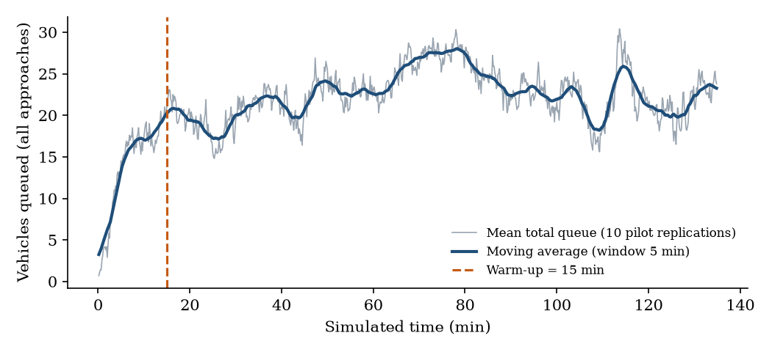
Figure 1. Warm-up check using Welch's method. The 15-minute warm-up is removed.

C. Baseline Performance (Research Question 1)
Table 4 presents the baseline results for each approach. Commonwealth Avenue (A1) is the most saturated entry, with a utilization of 0.94, a mean delay of 69 seconds, and level of service (LOS) F. Quezon Avenue (A4) follows with a utilization of 0.88, a mean delay of 37 seconds, and LOS E. The remaining four approaches operate at LOS A or B with delays of 8 to 13 seconds. For the whole roundabout, the mean delay is 31.0 ± 3.8 seconds per vehicle and the throughput is about 2,697 passenger car equivalents per hour. Figure 2 shows how the queues develop over time.
Table 4. Baseline results per approach (mean ± 95% CI, 30 replications)
 | Approach | Demand (PCE/h) | Circ. flow | Capacity | Utilization | Delay (s/veh) | Avg queue (veh) | Max queue | LOS
A1 | Commonwealth Ave | 660 | 661 | 703 | 0.94 | 69.2 ± 14.7 | 12.9 ± 2.8 | 66 | F
A2 | Visayas Ave | 300 | 1069 | 464 | 0.65 | 9.9 ± 0.3 | 0.8 ± 0.0 | 12 | A
A3 | North Ave | 380 | 899 | 552 | 0.69 | 8.4 ± 0.3 | 0.9 ± 0.0 | 13 | A
A4 | Quezon Ave | 620 | 663 | 702 | 0.88 | 36.9 ± 4.7 | 6.3 ± 0.8 | 41 | E
A5 | East Ave | 420 | 909 | 546 | 0.77 | 13.1 ± 0.7 | 1.5 ± 0.1 | 21 | B
A6 | Kalayaan Ave | 320 | 1105 | 447 | 0.72 | 10.6 ± 0.6 | 0.9 ± 0.1 | 10 | B

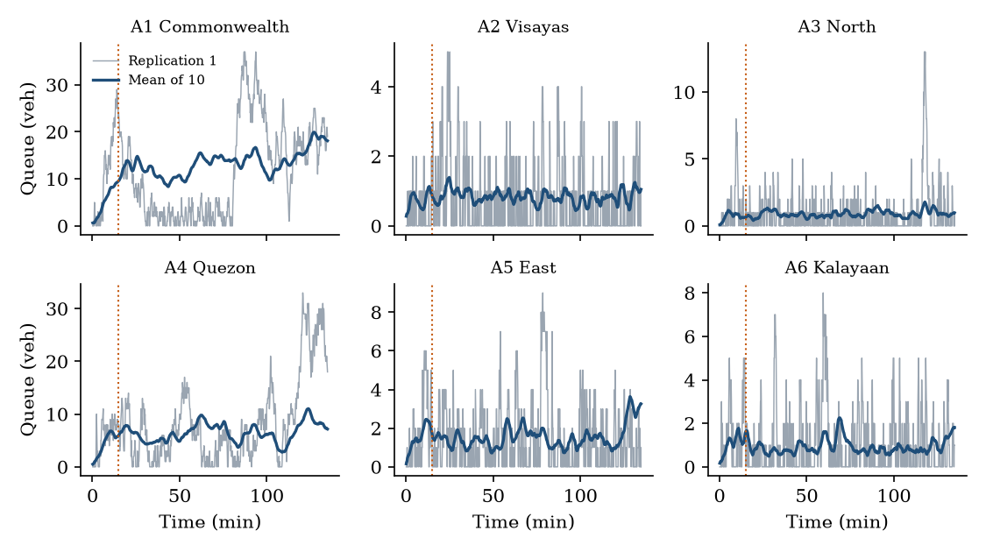
Figure 2. Queue length over time for each approach.

D. Validation Against Queuing Theory and HCM (Research Question 2)
Table 5 compares the simulated delay with the M/M/1, M/G/1, and HCM delay values. The M/G/1 model, which uses the service variability observed in the simulation, agrees with the simulation at the busy entries, within 1% at A1 and 3% at A4. At the lightly loaded approaches, both queuing formulas overestimate the delay. For example, at A2 the M/G/1 result is 19.3 seconds and the M/M/1 result is 22.0 seconds against 9.9 seconds simulated, because the formulas treat the capacity as a fixed service rate. The M/M/1 values are higher than the M/G/1 values because the simulated service time is less variable than the exponential assumption (CV² of about 0.6).
Table 5. Delay: simulation compared with M/M/1, M/G/1, and HCM (s/veh)
Approach | Simulation | M/M/1 | M/G/1 | HCM delay | Error vs HCM
A1 | 69.2 | 82.8 | 68.6 | 39.7 | 74%
A2 | 9.9 | 22.0 | 19.3 | 20.9 | 53%
A3 | 8.4 | 21.0 | 18.3 | 19.7 | 57%
A4 | 36.9 | 44.0 | 37.9 | 31.1 | 18%
A5 | 13.1 | 28.5 | 24.0 | 25.2 | 48%
A6 | 10.6 | 28.3 | 24.1 | 25.8 | 59%

Against the HCM delay formula, the simulation gives higher delay at the congested entries, A1 (+74%) and A4 (+18%), and lower delay at the lightly loaded entries (−48% to −59%). The mean absolute error is about 52%, which means that the simulated delay did not closely match the HCM delay. This outcome is reported as it was observed. A likely reason is that the HCM formula assumes a different treatment of the circulating flow and of the pedestrian blockage at A1 and A4 than the gap-acceptance rule used in the model. Throughput, on the other hand, matched the input volumes closely. The error was 1.0% or less for every approach, the GEH statistic was at most 0.19 (the usual threshold is 5), and the t-tests showed no significant difference (p = 0.12 to 0.93).
Table 6 compares the entry capacity measured under a permanent queue with the HCM equation. At A1 and A4, where the circulating flow is about 660 passenger car equivalents per hour, the simulated capacity is within 0.5% of the HCM value. At A2, A3, A5, and A6, where the circulating flow is between 900 and 1,100 per hour, the simulation gives a capacity that is 10% to 22% higher. This is consistent with the stated limitation that the HCM equation is a conservative reference for a large circulatory roadway such as the Elliptical Road.
Table 6. Entry capacity: simulation (saturated queue) compared with the HCM equation (PCE/h)
Approach | Circ. flow | HCM capacity | Simulated capacity (± 95% CI) | Difference
A1 | 669 | 697 | 694 ± 11 | -0.5%
A2 | 1066 | 465 | 547 ± 8 | +17.5%
A3 | 907 | 547 | 650 ± 8 | +18.8%
A4 | 674 | 694 | 692 ± 12 | -0.3%
A5 | 910 | 545 | 603 ± 8 | +10.5%
A6 | 1099 | 450 | 550 ± 10 | +22.3%

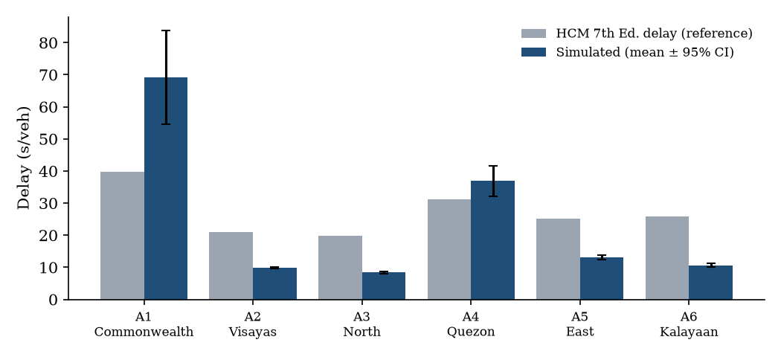
Figure 3. Simulated delay versus HCM delay (error bars show the 95% CI).
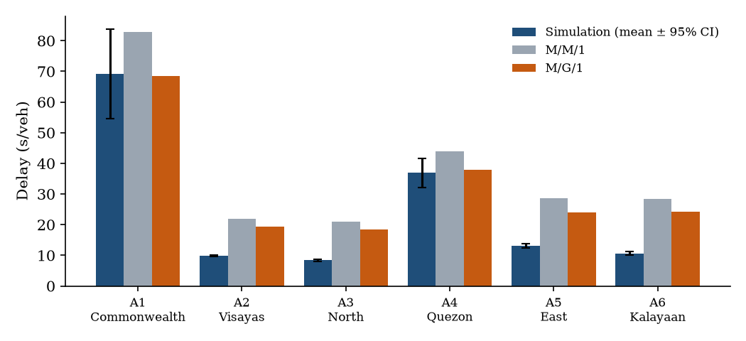
Figure 4. Simulated delay versus the M/M/1 and M/G/1 baselines.

E. Scenario Results (Research Question 3)
Table 7 summarizes the network-wide results of the scenarios. A one-way ANOVA showed that the scenarios differ significantly (F(5, 174) = 678.8, p < 0.001). Each scenario also differed significantly from the baseline in paired t-tests (Bonferroni-adjusted p < 0.001), and the nonparametric Wilcoxon test led to the same conclusion, which is important because the Shapiro-Wilk test showed that some of the paired differences were not normally distributed.
Table 7. Network-wide scenario results (mean ± 95% CI, 30 replications)
Scenario | Mean delay (s/veh) | Total queue (veh) | Throughput (PCE/h) | Max utilization | Change in delay
Baseline | 31.0 ± 3.8 | 23.4 ± 2.9 | 2697 | 0.94 | +0%
Metering signal (A6) | 38.3 ± 3.8 | 28.9 ± 2.9 | 2694 | 1.07 | +23%
Added entry lane (A1) | 16.7 ± 1.6 | 12.6 ± 1.2 | 2700 | 0.88 | -46%
Demand +10% | 136.3 ± 13.5 | 116.8 ± 11.7 | 2899 | 1.10 | +339%
Demand +20% | 312.2 ± 17.2 | 302.9 ± 18.3 | 3018 | 1.26 | +906%
Relocated pedestrian crossings | 13.3 ± 0.4 | 10.0 ± 0.4 | 2702 | 0.95 | -57%

Relocating the pedestrian crossings away from the yield lines produced the largest improvement, reducing the mean delay by 57% and the total queue from 23.4 to 10.0 vehicles. Adding an entry lane at Commonwealth Avenue reduced the delay by 46%. The metering signal at Kalayaan Avenue, with a 90-second cycle and a 60-second green, increased the delay by 23% and raised the maximum utilization to 1.07. The 10% and 20% demand increases raised the mean delay to 136 and 312 seconds, respectively, and pushed the maximum utilization above 1.0, which indicates that the circle operates beyond capacity.
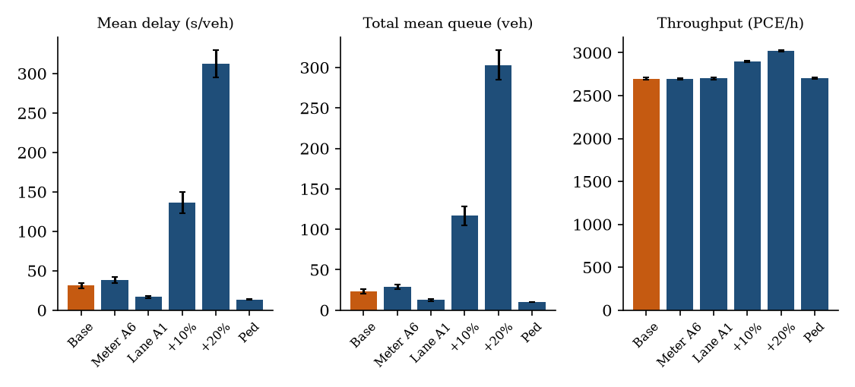
Figure 5. Scenario comparison of delay, queue, and throughput.
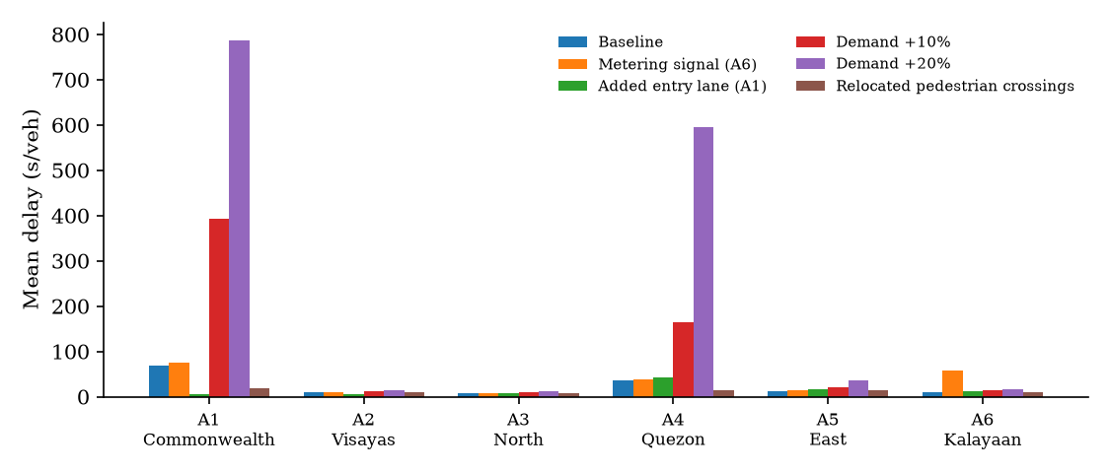
Figure 6. Mean delay by approach and scenario.

F. Sensitivity Analysis
Table 8 shows the change in network delay when one input at a time was varied. The network delay is most sensitive to the critical gap, where a value of 5.5 seconds increases delay by about 475%, followed by demand and the follow-up headway. The segment travel time has very little effect. Since the model is highly sensitive to the critical gap near capacity, measuring this parameter in the field is the most important next step for improving the credibility of the results.
Table 8. Change in network mean delay when one input is changed
Input | Range tested | Low value | High value | Rank
Critical gap t_c | 4.5 / 5.5 s | -35.7% | +474.6% | 1
Follow-up headway t_f | 2.3 / 2.9 s | -2.8% | +187.1% | 3
Demand | -10% / +10% | -56.9% | +312.7% | 2
Segment travel time | -20% / +20% | +0.3% | -4.3% | 5
Headway distribution | Erlang k = 2 | -21.7% |  | 4

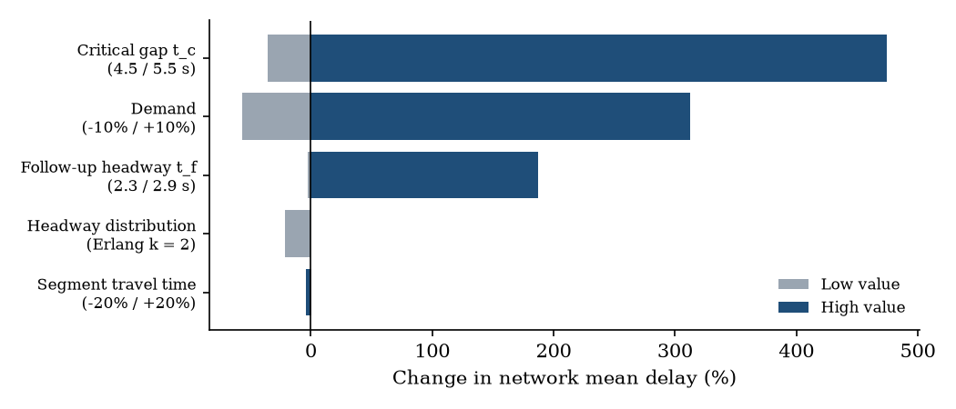
Figure 7. Sensitivity of network delay (tornado chart).

G. Ranked Recommendations
Based on the delay, queue length, and throughput results, the scenarios are ranked as follows. First, the relocation of pedestrian crossings away from the yield lines at A1 and A4 is recommended, since it gave the largest reduction in delay (31.0 to 13.3 seconds). Second, the addition of an entry lane at Commonwealth Avenue is recommended, since it reduced the delay to 16.7 seconds and lowered the maximum utilization to 0.88. Third, retaining the current layout is possible, but Commonwealth Avenue is already near capacity at a utilization of 0.94. Fourth, the tested metering signal at Kalayaan Avenue is not recommended because it worsened the delay by 23%. Finally, demand management or added capacity should be prepared before traffic grows, because a 10% increase already causes a breakdown in operation. These rankings hold only under the assumed inputs and the single-lane gap-acceptance model.

H. Output Files
The deliverables of the study are the documented SimPy program (roundabout_sim.py) and its Jupyter notebook (roundabout_sim.ipynb), which include the instructions needed to reproduce the runs. A results folder contains the CSV tables behind every table in this report and the charts of delay, queue length, and utilization by approach, the capacity comparison, the confidence interval charts, and the scenario comparison. This report and the ranked recommendations complete the outputs.

VIII. Schedule of Activities
Table 9 shows the schedule of activities followed in the project.
Table 9. Project schedule
Activity | Timeline
Proposal: define the problem, objectives, scope, and methods; initial site visit | Week 1-2
Data collection: traffic counts, video of gaps, geometry; estimate arrival rates and gap parameters | Week 3-5
Model development: queuing baseline and SimPy model coding | Week 5-7
Testing: verification, validation, replications, and scenario runs | Week 7-9
Presentation: finalize report, charts, recommendations, and present the findings | Week 9-11

IX. Resources Used
The study used a laptop computer, an internet connection for references, map services, and shared project files, and the following software: Python with SimPy, NumPy, pandas, SciPy, and Matplotlib, together with Jupyter Notebook and spreadsheet software. The HCM 7th Edition and NCHRP Report 1043 served as the sources of parameters and guidance (NASEM, 2022, 2023), and geometric data were taken from maps. Field counts and video recordings were not collected.

X. Benefits
Commuters, drivers, and pedestrians may benefit from improvements that reduce waiting time and conflict at the circle. For the school, the project demonstrates applied modeling and simulation skills and may serve as a reference for future student studies. For the LGU and MMDA, the model is an evidence-based tool for comparing signal metering, lane additions, and pedestrian crossing options before any field implementation. For researchers, the data, code, and method can be reused or extended, for example through microsimulation or the study of automated vehicles at roundabouts (Tumminello et al., 2022).

XI. Conclusion
This project applied queuing theory, gap-acceptance modeling, and discrete-event simulation to the Quezon Memorial Circle and validated the model against the HCM 7th Edition. Under the assumed peak inputs, Commonwealth Avenue (A1) and Quezon Avenue (A4) are the bottlenecks, with utilizations of 0.94 and 0.88 and mean delays of 69 and 37 seconds. The model passed all eight verification tests, reproduced the input volumes within 1%, agreed closely with the M/G/1 baseline at the busy entries, and matched the HCM capacity at A1 and A4. It did not closely match the HCM delay formula, and its capacity was 10% to 22% higher than the HCM at the other approaches.
Among the options tested, relocating the pedestrian crossings (−57% delay) and adding an entry lane at Commonwealth Avenue (−46%) were the most effective, while the tested metering signal at Kalayaan Avenue worsened the delay (+23%) and a demand growth of 10% to 20% pushed the circle beyond capacity. The main limitation of the study is the absence of field data. It is therefore recommended that traffic counts and gap observations be collected, that the CONFIG values be replaced with them, and that the notebook be re-run to confirm these findings.

XII. References
Al Hasanat, H., & Schuchmann, G. (2022). Critical gap in roundabouts. Periodica Polytechnica Transportation Engineering, 50(3), 273–278. https://doi.org/10.3311/PPtr.18632
Cochero, J., Dotillos, Y. V., Petilos, L. M., Tañola, E. N., Ando, L. J., & Mejia, H. (2025). Determining an optimal intersection traffic management scheme through microsimulation. Proceedings of the 32nd Annual Conference of the Transportation Science Society of the Philippines (TSSP 2025). https://ncts.upd.edu.ph/tssp/wp-content/uploads/2026/02/TSSP2025-31-Revised-Paper.pdf
Eugenio, A. C. B., Nagales, A. C., Ong, J. M. C., Sauquillo, B. L., Tanguin, K. J., Lambino, D. C. A., & De Jesus, K. L. M. (2023). Traffic simulation evaluation of the proposed Commonwealth Avenue–East Avenue interchange using PTV VISSIM. 2023 IEEE 15th International Conference on Humanoid, Nanotechnology, Information Technology, Communication and Control, Environment, and Management (HNICEM). https://doi.org/10.1109/HNICEM60674.2023.10589204
Esugo, M., Haas, O., & Lu, Q. (2024). Hybrid deep-learning approach with Geoffrey E. Havers-based loss function and evaluation metric for multilocation traffic-flow forecasting. Transportation Research Record. https://doi.org/10.1177/03611981241274645
Guastella, D. A., et al. (2023). Traffic modeling with SUMO: A tutorial (arXiv:2304.05982). arXiv. https://arxiv.org/abs/2304.05982
Law, A. M. (2024). Simulation modeling and analysis (6th ed.). McGraw-Hill. https://www.mheducation.com
Majid, H., & Jabari, H. (2023). Comparative evaluation of roundabout capacities methods for single-lane and multi-lane roundabout. Journal of Engineering, 29(3), 76–97. https://doi.org/10.31026/j.eng.2023.03.06
National Academies of Sciences, Engineering, and Medicine. (2022). Highway capacity manual 7th edition: A guide for multimodal mobility analysis. The National Academies Press. https://doi.org/10.17226/26432
National Academies of Sciences, Engineering, and Medicine. (2023). Guide for roundabouts (NCHRP Report 1043). The National Academies Press. https://doi.org/10.17226/27069
Previati, G., & Mastinu, G. (2023). SUMO roundabout simulation with human in the loop. SUMO Conference Proceedings, 4, 29–40. https://www.tib-op.org/ojs/index.php/scp
Radu, A. I., Tolea, B. A., Beles, H., Scurt, F. B., & Iclodean, C.-D. (2026). Evaluating roundabout performance using agent-based simulation: A case study. Electronics, 15(15), 3332. https://doi.org/10.3390/electronics15153332
Raymundo, J. C. M., Vergel, D. C., & Gaspay, S. M. A. (2024). Passenger car equivalent factor for tricycles in urban local roads within Metro Manila. Proceedings of the 31st Annual Conference of the Transportation Science Society of the Philippines (TSSP 2024). https://ncts.upd.edu.ph/tssp/wp-content/uploads/2024/12/TSSP2024-27-Revised-Paper.pdf
Rosario, J., Dolores, A. J., Lim, M. B., Sundo, M., & Reynoso, C. (2025). Assessing the effect of signalizing the Romulo Highway and Tibag-San Isidro Road intersection in Tarlac City, Philippines using a locally developed microsimulation software. In S. Tangtermsirikul, P. Warnitchai, K. Panuwatwanich, & G. Tanapornraweekit (Eds.), Proceedings of the 18th East Asia-Pacific Conference on Structural Engineering and Construction, Vol. 3 (Lecture Notes in Civil Engineering, Vol. 726). Springer. https://doi.org/10.1007/978-981-95-0090-1_20
Santos, K. (2024, June 13). A guide to the historic roundabouts and road monuments in Metro Manila. Top Gear Philippines. https://www.topgear.com.ph/features/feature-articles/historic-roundabouts-monuments-metro-manila-a4682-20240613-lfrm
Tumminello, M. L., Macioszek, E., Granà, A., & Giuffrè, T. (2022). Simulation-based analysis of “what-if” scenarios with connected and automated vehicles navigating roundabouts. Sensors, 22(17), 6670. https://doi.org/10.3390/s22176670

